
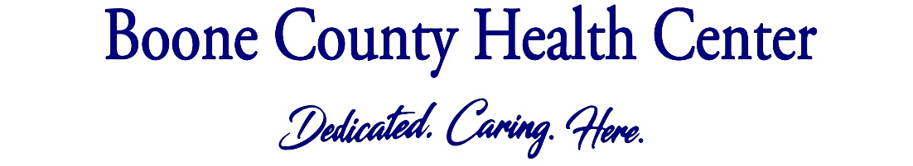

7TH GRADE SCHOOL PHYSICAL
Your daughter/son will be having a 7th grade physical this year. Here’s what to expect:
Vaccines. Your child will get three vaccines recommended by the Centers for Disease Control and Prevention (CDC) to prevent cancer and meningitis. Both of these sicknesses can cause long term illness, so a shot will help protect your child:
- HPV – Gardasil
- Tdap – Tetanus
- Meningococcal – Meningitis
*If your child is on Medicaid or you have no insurance, make sure you come to the clinic in Albion for vaccines. Families with private insurance can get vaccines at any of our clinics.
Exam. We will check a urine sample and do a basic eye exam. We will also check for other health issues, just as we did at checkups when your child was younger.
Talk. We will talk with your child about sleep, physical activity, nutrition, relationships, decision making and much more. This is a great time for parents to ask questions or talk about concerns they have for their child’s well-being. Also, your child will have a chance to talk to their medical provider alone about anything they may be worried about if they would like.
What to Bring:
Wear contacts or glasses if you have them
Full bladder – so we can get a urine sample
Immunization record
A parent-this age is a huge milestone not only for your child but also for you as a parent
When to schedule: Any time before your child starts their 7th grade school year but the sooner the better as the schedule gets full in July and August.
How to schedule: Call your local clinic to schedule your daughter or sons 7th grade physical.

Boone County Medical Clinic: 402-395-5013
Cedar Rapids Medical Clinic: 308-358-0615
Elgin Veterans’ Medical Clinic: 402-843-5910
Nance County Medical Clinic: 308-536-2446
Newman Grove Medical Clinic: 402-447-6214
Spalding Medical Clinic: 308-497-2485
St. Edward Medical Clinic: 402-678-2232

